**SUMMER PROJECT REPORT**

**ON**

**“EMPLOYEE WELFARE”**

**IN**

**NHPC CHAMERA POWER STATION-II**

SUBMITTED IN PARTIAL FULFILLMENT OF

DEGREE OF

MASTERS OF BUSINESS ADMINISTRATION

SESSION (2009-2011)

# PAPER CODE-(CP-303)

### SUBMITTED BY:

**KARAN SINGH**

MBA 3rd SEM

University Roll No.

## SUBMITTED TO

ICL INSTITUTE OF ENGINEERING AND TECHNOLOGY

SOUNTLI

(KURUKSHETRA UNIVERSITY, KURUKSHETRA)

##### **DECLARATION**

I hereby declare that, the project entitled **“*EMPLOYEE WELFARE”*** assigned to me for the partial fulfillment of MBA degree from Kurukshetra University, Kurukshetra. The work is originally completed by me and the information provided in the study is authentic to the best of my knowledge.

This study has not been submitted to any other institution or university for the award of any other degree.

KARAN SINGH

MBA 3rd SEM

University Roll No.

**ACKNOWLEDGEMENT**

“***Gratitude is the hardest of emotions to express and one often does not find adequate words to convey what one feels and trying to express it***”

The present project file is an amalgamated of various thoughts and experiences .The successful completion of this project report would have not been possible without the help and guidance of number of people and especially to my project guide in the company ***Mr. Surya Kumar Chauhan A.M (HR), NHPC CPS-II***. I take this opportunity to thank all those who have directly and indirectly inspired, directed and helped me towards successful completion of this project report.

I am also immensely indebted to my project guide, ***Mr. Kapil Aggarwal*** Assistant Professor, ICL, for his illumining observation, encouraging suggestions and constructive criticisms, which have helped me in completing this research project successfully.

There are several other people who also deserve much more than a mere acknowledgement at their exemplary help. I also acknowledge with deep sense of gratitude and wholehearted help and cooperation intended to me by them.

**KARAN SINGH**

**PREFACE**

Summer Training is the bridge for a student that takes him from his theoretical knowledge world to practical industry world. The main purpose of industrial visit is to expose for industrial and business environment, which cannot be possible in the classroom.

The advantages of this sort of integration, which promotes guided to corporate culture, functional, social and norms along with formal teaching are numerous.

1. To bridge the gap between theory and practical.
2. To install the feeling of belongingness and acceptance.
3. To help the student to develop the better understanding of the concept and questions already raised or to be raised subsequently during their research period.

The present report gives a detailed view of the ***EMPLOYEE WELFARE***. The research is definitely going to play an important role in developing an aptitude for hard self-confidence.

**CONTENTS**

|  |  |
| --- | --- |
| 1. CHAPTER-1 INTRODUCTION TO    * + INDUSTRY      + COMPANY      + PROJECT 2. CHAPTER -2   OBJECTIVES   1. CHAPTER-3   RESEARCH METHODOLOGY   1. CHAPTER-4   ANALYSIS AND INTERPRETATION   1. CHAPTER-5   FINDINGS   1. CHAPTER-6   LIMITATIONS   1. CHAPTER-7   RECOMMENDATIONS   1. CHAPTER-8   CONCLUSION   * BIBLIOGRAPHY * ANNEXURE |  |

**CHAPTER - 1**

**INTRODUCTION OF NHPC LTD.**

**National Hydroelectric Power Corporation**

|  |  |
| --- | --- |
| **NHPC Limited** | |
| [NHPC logo.png](http://en.wikipedia.org/wiki/File:NHPC_logo.png) | |
| **Type** | Public |
| **Industry** | Hydro-electric Power Generation |
| **Founded** | 1975 |
| **Headquarters** | Faridabad, India |
| **Key people** | S K Garg, Chairman & Managing Director |
| **Products** | Electricity |
| **Website** | http://www.nhpcindia.com |

NHPC Limited (Formerly known as National Hydroelectric Power Corporation Ltd.), A Govt. of India Enterprise, was incorporated in the year 1975 with an authorized capital of Rs. 2000 million and with an objective to plan, promote and organize an integrated and efficient development of hydroelectric power in all aspects.   Later on NHPC expanded its objects to include development of power in all its aspects through conventional and non-conventional sources in India and abroad.

At present, NHPC is a Mini Ratna Category-I Enterprise of the Govt. of India with an authorized share capital of Rs. 1,50,000 Million . With an investment base of over Rs. 3, 17,000 Million Approx. , NHPC is among the TOP TEN companies in the country in terms of investment.

Initially, on incorporation, NHPC took over the execution of Salal Stage-I, Bairasiul and Loktak Hydro-electric Projects from Central Hydroelectric Project Construction and Control Board. Since then, it has executed 13   projects with an installed capacity of 5175 MW on ownership basis including projects taken up in joint venture. NHPC has also executed 5 projects with an installed capacity of 89.35 MW on turnkey basis. Two of these projects have been commissioned in neighboring countries i.e. Nepal and Bhutan.

During the financial year 2008-2009, NHPC Power Stations achieved the highest ever generation of electricity**.**

|  |
| --- |
| **GENERATION** |
|  |
| http://www.nhpcindia.com/writereaddata/English/Images/11_1.jpg |

**HISTORY OF NHPC**

Our Company was incorporated on November 7, 1975 under the Companies Act as a private limited company under the name `National Hydro Electric Power Corporation Private Limited'. The word `private' was subsequently deleted on September 18, 1976. Our Company was converted to a public limited company w.e.f. April 2, 1986. Pursuant to a shareholders resolution dated March 13, 2008, the name of our Company was changed to its present name `NHPC Limited' and a fresh certificate of incorporation consequent upon change of name was issued by the RoC, National Capital Territory of Delhi and Haryana, on March 28, 2008.

Major events

Financial Year Event

1975 - 76 Incorporation of our Company

1976 - 77 Transfer of the Loktak hydroelectric project (105 MW) from GoI to our Company

1977 - 78 Transfer of the Baira Siul hydroelectric project (180 MW) from GoI to our Company

1982 - 83 Baira Siul power station (180 MW) in Himachal Pradesh commissioned

1983 - 84 All units of Devighat power station in Nepal commissioned ahead of schedule Loktak power station (105 MW) in Manipur commissioned

1985 - 86 Hydro Power Training Institute set up at the Baira Siul hydroelectric project to train operators and supervisory staff

1986 - 87 First issue of 14% 7 years, redeemable secured non convertible bonds amounting to Rs. 143.64 crore

Nuwakot Rural Electrification project in Nepal completed ahead of schedule

1987 - 88 Establishment of a satellite telecommunication network taken up to link various projects of our Company

1989 - 90 GoI upgraded our Company from a Schedule `B' to a Schedule `A' corporation

1992 - 93 A consultancy wing set up to provide a range of specialized services in the investigation, design, construction and operation of hydel projects

Tanakpur power station (120 MW) in Uttarakhand commissioned

1994 - 95 awarded the lining work of Jawahar Tunnel in Jammu & Kashmir

Our Company declared its maiden dividend of Rs. 5 crore for the year ending March 31, 1994

Our Company's registered office started operating from its present building in Faridabad Chamera I power station (540 MW) in Himachal Pradesh commissioned

1995 - 96 Agreement signed for execution of Kurichhu hydroelectric project (45 MW) in Bhutan

1997 - 98 Uri power station (480 MW) in Jammu & Kashmir commissioned

1999 - 2000 Rangit power station (60 MW) in Sikkim commissioned

2000 - 01 Three units of 45 MW Kurichhu power station in Bhutan commissioned by our Company ahead of schedule

Our Company and the government of Madhya Pradesh entered into an MoU to exploit the hydro electric potential of the Narmada basin by completing the Indira Sagar and Omkareshwar projects

Our Company and the government of Jammu & Kashmir entered into an MoU to exploit the power potential of the state

2002 - 03 A line of credit for a tenor of 19 years taken from LIC for an amount of Rs. 2,500 crore

Our Company was accorded `AAA' credit rating for domestic borrowing and `BB' credit rating at par with sovereign rating of international borrowings by Fitch Ratings

2003 - 04 Chamera- II power station (300 MW) in Himachal Pradesh commissioned

2004 - 05 Indira Sagar hydroelectric project (1,000 MW) of NHDC, a joint venture of our Company and the government of Madhya Pradesh in Madhya Pradesh commissioned

2005 - 06 ERP initiated under the name Project Kiran

2006 - 07 Our Company entered into an agreement with Government of Bhutan for preparation of DPR of Mangdechhu project (672 MW) in Bhutan

2007 - 08 The name of our Company changed to its present name NHPC Limited Dulhasti power station (390 MW) commissioned

Teesta-V power station (510 MW) commissioned

Omkareshwar hydroelectric project (520 MW) of NHDC, a joint venture of our Company and the government of Madhya Pradesh, commissioned

Our Company entered into an MoA with the government of Arunachal Pradesh to execute the Dibang multipurpose hydroelectric project

Our Company entered into an MoU with the government of Manipur to exploit the hydro electric potential of the tailrace discharge of Loktak Downstream Hydroelectric Project

2008 - 09 Our Company conferred Mini Ratna Category I status by the GoI

Our Company entered into an MoU with the government of Jammu & Kashmir, JKSPDC and PTC to incorporate a joint venture develop the Pakal Dul and other hydro projects in the Chenab River Basin

Incorporation of joint venture company, National Power Exchange Limited, along with NTPC, PFC and Tata Consultancy Services Limited

- NHPC Ltd has appointed Shri. Sudhir Kumar, Joint Secretary (Hydel), Ministry of Power as Part-time Director on the Board of the Company with effect from October 21, 2009.

- NHPC Ltd has informed that Ministry of Power has informed the approval of appointment of Shri A. Gopalakrishnan as part-time non-official Director by the President of India on the Board of NHPC Ltd.

2009-10 Incorporation of a joint venture company, National High Power Test Laboratory Private Limited, along with NTPC, Powergrid Corporation of India Limited and Damodar Valley Corporation.

**NHPC PROJECTS IN INDIA**

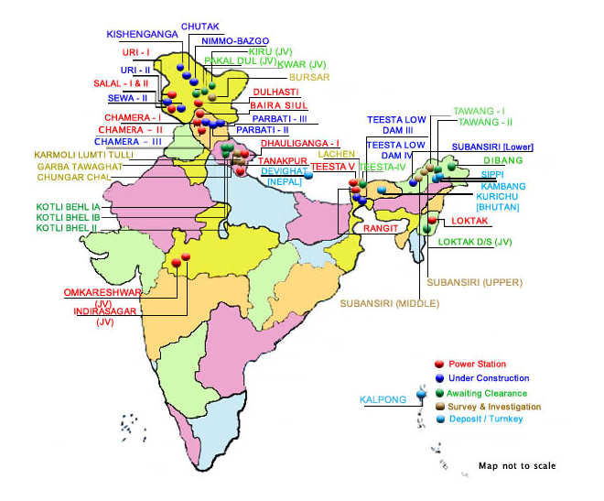

**CORPORATE PROFILE**

|  |  |
| --- | --- |
| Authorized Capital | Rs. 1,50,000 Million |
| Value of Assets | Rs. 3,17,000 Million Approx. |
| Paid Up Capital | Rs. 111,820 Million 31.03.2009 |
| Projects Completed | 13 Nos. (5175 MW) |
| [Projects Under Construction](http://www.nhpcindia.com/English/Scripts/Project_Construction.aspx) | 11 Nos. (4622 MW) |
| [Projects Awaiting Clearances](http://www.nhpcindia.com/English/Scripts/project_underdevelopment_link.aspx?vid=4&id2=Awaiting%20clearances) | 9 Nos. (8131 MW) |
| [Projects Under Survey and Investigation Stage](http://www.nhpcindia.com/English/Scripts/project_underdevelopment_link.aspx?vid=5&id2=Under%20Survey%20and%20Investigation%20Stage) | 7 Nos. (5755 MW) |
| [Joint Venture Projects](http://www.nhpcindia.com/English/Scripts/Projects_JointVenture.aspx) | 4 Nos. (3686 MW) |
| [Projects on Turnkey Basis](http://www.nhpcindia.com/English/Scripts/Project_depositturnkey.aspx) | 5 Nos. (89.35 MW) |

|  |  |
| --- | --- |
| **In 2008-2009** | |
| Energy Generated | 16689.59 MU |
| Capacity Index | 93.61% |
| Sales Turnover | 26980.6 Million |
| Net Profit | Rs. 10752.2 Million |
| **In 2007-2008** | |
| Energy Generated | 14813.16 MU |
| Capacity Index | 96.12% |
| Sales Turnover | 23010 Million |
| Net Profit | Rs. 10040.9 Million |
| Performance Rating | "Excellent" |

**OBJECTIVES OF NHPC**

|  |  |  |  |  |  |  |  |  |  |  |  |  |
| --- | --- | --- | --- | --- | --- | --- | --- | --- | --- | --- | --- | --- |
| |  |  | | --- | --- | |  | * To Plan, promote and organize an integrated and efficient development of power in all its aspects through Conventional and Non Conventional Sources in India and Abroad subject to clause 1 (b), including planning, investigation, research, design and preparation of preliminary, feasibility and definite project reports, construction, generation, operation and maintenance of power stations and projects, transmission, distribution, trading and sale of power generated at Stations in accordance with the national economic policy and objectives laid down by the Central Government from time to time and release of water and other needs to the State Govt. as per the agreed parameters. | |  | * To Plan, promote and organize an integrated and efficient development of Thermal Power in all its aspects through its subsidiary Company i.e. Narmada Hydroelectric Development Corporation Limited including planning, investigation, research, design and preparation of preliminary, feasibility and definite project reports, construction, generation, operation and maintenance of power stations and projects, transmission, distribution, trading and sale of power generated at Stations. | |  | * To undertake, where necessary, the construction of inter-state transmission lines and ancillary works for timely and coordinated inter-state exchange of power. | |  | * To coordinate the activities of its subsidiaries, to determine their economic and financial objectives / targets and to review, control, guide and direct their performance with a view to secure optimum utilization of all resources placed at their disposal. | |  | * To act as an agent of Government / Public Sector financial institutions, to exercise all the rights and powers exercisable at any meeting of any Company engaged in the planning, investigation, research, design and preparation of preliminary, feasibility and definite project reports, construction, generation, operation, maintenance of Power Stations and Projects, transmission, distribution, trading and sale of power in respect of any shares held by the Government, Public financial institutions, nationalized banks, nationalized insurance companies with a view to secure the most effective utilization of the financial investments and loans in such companies and the most efficient development of the concerned industries. | |  | * To carry on the business of purchasing, selling, importing, exorting, producing, trading, manufacturing or otherwise dealing in all aspects of planning, investigation, research, design and preparation of preliminary, feasibility and definite project reports, construction, generation, operation and maintenance of Power Stations and Projects, transmission, distribution and sale of Power, Power Development, including forward, backward or horizontal integration ancillary and other allied industries and for that purpose to install, operate and manage all necessary plants, establishments and works. | |
|  |

**MISSION OF NHPC**

|  |
| --- |
| * To achieve international standards of excellence in all aspects of hydro power and diversified business. |
| * To execute and operate projects in a cost effective, environment friendly and socio-economically responsive manner. |
| * To foster competent trained and multi-disciplinary human capital. |
| * To continually develop state-of-the-art technologies through innovative R&D and adopt best practices. |
| * To adopt the best practices of corporate governance and institutionalize value based management for a strong corporate identity. |
| * To maximize creation of wealth through generation of internal funds and effective management of resources. |

**VISION OF NHPC**

A world class, diversified & transnational organization for sustainable development of hydro power and water resources with strong environment conscience.

To continually develop state-of-the-art technologies through innovative R&D and adopt best practices.

HYDRO POWER STATIONS

### Hydro Power Stations

**Total - 5175 MW**

|  |  |  |  |  |
| --- | --- | --- | --- | --- |
| **S.no.** | **Power Plant** | **State** | **Commissioned Capacity (MW)** | **year of commission** |
| 1 | [Baira siul](http://en.wikipedia.org/w/index.php?title=Baira_siul&action=edit&redlink=1) | [Himachal Pradesh](http://en.wikipedia.org/wiki/Himachal_Pradesh) | 180 | 1981 |
| 2 | [Loktak](http://en.wikipedia.org/wiki/Loktak) | [Manipur](http://en.wikipedia.org/wiki/Manipur) | 105 | 1983 |
| 3 | [Salal-I](http://en.wikipedia.org/w/index.php?title=Salal-I&action=edit&redlink=1) | [Jammu & Kashmir](http://en.wikipedia.org/wiki/Jammu_%26_Kashmir) | 345 | 1987 |
| 4 | [Tanakpur](http://en.wikipedia.org/wiki/Tanakpur) | [Uttarakhand](http://en.wikipedia.org/wiki/Uttarakhand) | 120 | 1992 |
| 5 | [Chamera-I](http://en.wikipedia.org/w/index.php?title=Chamera-I&action=edit&redlink=1) | [Himachal Pradesh](http://en.wikipedia.org/wiki/Himachal_Pradesh) | 540 | 1994 |
| 6 | [Salal-II](http://en.wikipedia.org/w/index.php?title=Salal-II&action=edit&redlink=1) | [Jammu & Kashmir](http://en.wikipedia.org/wiki/Jammu_%26_Kashmir) | 345 | 1996 |
| 7 | [Uri-I](http://en.wikipedia.org/wiki/Uri-I) | [Jammu & Kashmir](http://en.wikipedia.org/wiki/Jammu_%26_Kashmir) | 480 | 1997 |
| 8 | [Rangit](http://en.wikipedia.org/w/index.php?title=Rangit&action=edit&redlink=1) | [Sikkim](http://en.wikipedia.org/wiki/Sikkim) | 60 | 1999 |
| 9 | [Chamera-II](http://en.wikipedia.org/w/index.php?title=Chamera-II&action=edit&redlink=1) | [Himachal Pradesh](http://en.wikipedia.org/wiki/Himachal_Pradesh) | 300 | 2004 |
| 10 | [Indira sagar](http://en.wikipedia.org/w/index.php?title=Indira_sagar&action=edit&redlink=1) | [Madhya Pradesh](http://en.wikipedia.org/wiki/Madhya_Pradesh) | 1000 | 2005 |
| 11 | [Dhauliganga-I](http://en.wikipedia.org/w/index.php?title=Dhauliganga-I&action=edit&redlink=1) | [Uttarakhand](http://en.wikipedia.org/wiki/Uttarakhand) | 280 | 2005 |
| 12 | [Dul Hasti](http://en.wikipedia.org/wiki/Dul_Hasti) | [Jammu & Kashmir](http://en.wikipedia.org/wiki/Jammu_%26_Kashmir) | 390 | 2007 |
| 13 | [Omkareshwar](http://en.wikipedia.org/wiki/Omkareshwar) | [Madhya Pradesh](http://en.wikipedia.org/wiki/Madhya_Pradesh) | 520 | 2007 |
| 14 | [Teesta-V](http://en.wikipedia.org/w/index.php?title=Teesta-V&action=edit&redlink=1) | [Sikkim](http://en.wikipedia.org/wiki/Sikkim) | 510 | 2008 |

### Hydro Power Stations Under construction

**Total - 4622 MW**

|  |  |  |  |  |
| --- | --- | --- | --- | --- |
| **S.no.** | **Power Plant** | **State** | **Total Capacity (MW)** | **Completion Schedule** |
| 1 | [Sewa-II](http://en.wikipedia.org/w/index.php?title=Sewa-II&action=edit&redlink=1) | [Jammu & Kashmir](http://en.wikipedia.org/wiki/Jammu_%26_Kashmir) | 120 | 2011 |
| 2 | [Teesta Low Dam-III](http://en.wikipedia.org/w/index.php?title=Teesta_Low_Dam-III&action=edit&redlink=1) | [West Bengal](http://en.wikipedia.org/wiki/West_Bengal) | 132 | 2011 |
| 3 | [Parbati-II](http://en.wikipedia.org/w/index.php?title=Parbati-II&action=edit&redlink=1) | [Himachal Pradesh](http://en.wikipedia.org/wiki/Himachal_Pradesh) | 800 | 2013 |
| 4 | [Subansiri (Lower)](http://en.wikipedia.org/wiki/Subansiri_(Lower)) | [Assam](http://en.wikipedia.org/wiki/Assam) | 2000 | 2012 |
| 5 | [Chamera-III](http://en.wikipedia.org/w/index.php?title=Chamera-III&action=edit&redlink=1) | [Himachal Pradesh](http://en.wikipedia.org/wiki/Himachal_Pradesh) | 231 | 2010 |
| 6 | [Teesta Low Dam-IV](http://en.wikipedia.org/w/index.php?title=Teesta_Low_Dam-IV&action=edit&redlink=1) | [West Bengal](http://en.wikipedia.org/wiki/West_Bengal) | 160 | 2011 |
| 7 | [Parbati-III](http://en.wikipedia.org/w/index.php?title=Parbati-III&action=edit&redlink=1) | [Himachal Pradesh](http://en.wikipedia.org/wiki/Himachal_Pradesh) | 520 | 2010 |
| 8 | [Nimmo-Bazgo](http://en.wikipedia.org/w/index.php?title=Nimmo-Bazgo&action=edit&redlink=1) | [Jammu & Kashmir](http://en.wikipedia.org/wiki/Jammu_%26_Kashmir) | 45 | 2010 |
| 9 | [Chutak](http://en.wikipedia.org/w/index.php?title=Chutak&action=edit&redlink=1) | [Jammu & Kashmir](http://en.wikipedia.org/wiki/Jammu_%26_Kashmir) | 44 | 2011 |
| 10 | [Uri-II](http://en.wikipedia.org/wiki/Uri-II) | [Jammu & Kashmir](http://en.wikipedia.org/wiki/Jammu_%26_Kashmir) | 240 | 2011 |
| 11 | [Kishenganga](http://en.wikipedia.org/w/index.php?title=Kishenganga&action=edit&redlink=1) | [Jammu & Kashmir](http://en.wikipedia.org/wiki/Jammu_%26_Kashmir) | 330 | 2016 |

PROJECTS UNDER GOVT. CLEARANCE

**TOTAL 9631 MW**

**Project State Capacity**

Kotli Bhel-1A Uttarakhand 195 MW

Kotli Bhel-1B Uttarakhand 320 MW

Kotli Bhel-II Uttarakhand 530 MW

Dibang Arunachal Pradesh 3000 MW

Tawang-I Arunachal Pradesh 600 MW

Tawang-II Arunachal Pradesh 800 MW

Teesta-IV Sikkim 520 MW

Loktak Downstream (JV)1 Manipur 66 MW

Pakal-Dul & Other Projects (JV)2 Jammu & Kashmir 2100 MW

Tipaimukh (JV)3 Manipur 1500 MW

**INTRODUCTION OF CHAMERA POWER STATION-II**

|  |
| --- |
| C:\Users\karan\Desktop\DSCF2692[1].jpg |
| Construction of Chamera HE Project Stage-II has been taken up for harnessing untapped potential river Ravi in its upper reaches. The project is a run of the river scheme with 300 MW installed capacity. The project lies within Lesser Himalayan terrain and will housed within competent metamorphic of Chamba Formation and Dhauladhar Granites. The project generates 1499.89 million units in a 90% dependable year which is fed to the northern grid. With the construction of the project the area has also benefitted by development of infrastructure, education and medical facilities. |

PLANT LAYOUT OF CPS-II

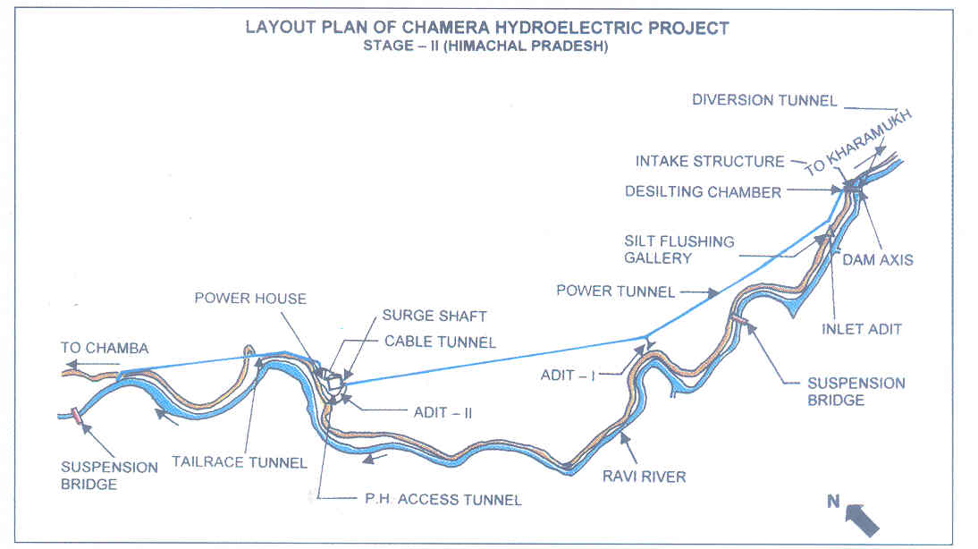

**FEATURES OF CHAMERA POWER STATION-II**

|  |  |
| --- | --- |
| **SALIENT FEATURES** | |
| Location | Distt. Chamba in Himachal Pradesh. |
| Approach | Nearest Rail Head - Pathankot. |
| Capacity | 300 MW (3 x 100 MW) |
| Annual Generation | 1499.89 MUs |
| Project Cost | Rs.1929.57 crores (Completion cost) |
| Beneficiary States | Uttranchal, U.P., Delhi, H.P., Haryana, J&K, Punjab, Rajasthan & Chandigarh |
| Year of Commissioning/Completion Schedule | March 2004 |
|  | |
| **TECHNICAL FEATURES** | |
| * 39 m high, 118.50 m long Concrete Gravity Dam. * 7.0 m dia circular shape, 7.86 km long Head Race Tunnel. * 7.0 m dia circular shape, 3.6 km long Tail Race Tunnel. * Underground Power House containing 3 units of 100 MW each.   . | |

**MAJOR COMPONENTS**

**Concrete Dam**

A 43m high concrete gravity dam has been constructed for impounding of water. For passing of flood discharge,4 Nos. spillway bays with radial gates of size 15m(width)*21.97m(height) have been provided, which are Asia’s largest gates.

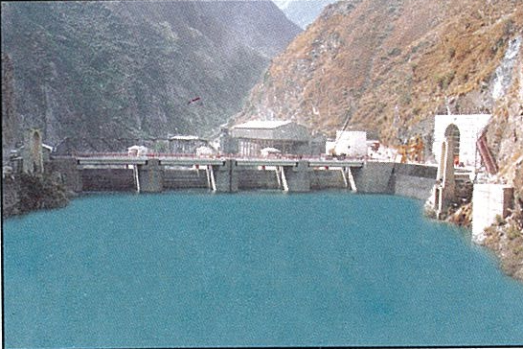

**Upstream view of concrete Dam**

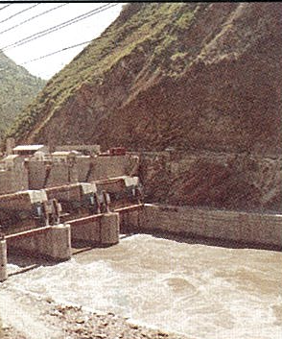 **Downstream view of Concrete Dam**

**Desilting Chamber**

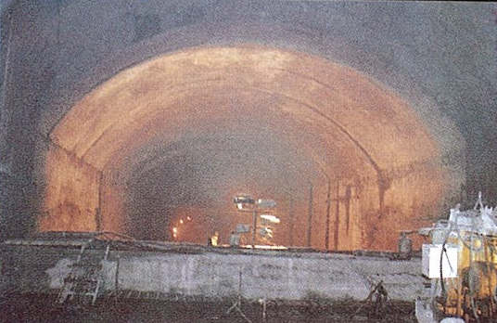

Two parallel underground compartment of size 375(l)*1 m (w) *21.75m (ht.) has been Provided for exclusion Of silt particles of size greater than .2mm

**Head Race Tunnel** 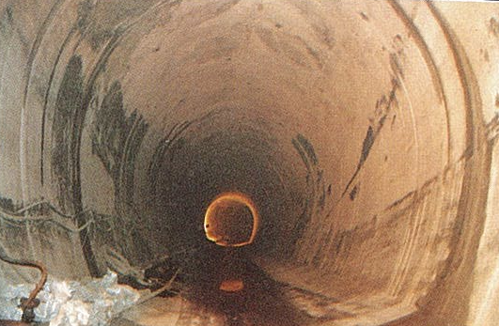

7-831 KM long Horseshoe shape Plain concrete line power tunnel designed to carry discharge of 142 Cumecs of water.

**Surge Shaft &Pressure Shaft**

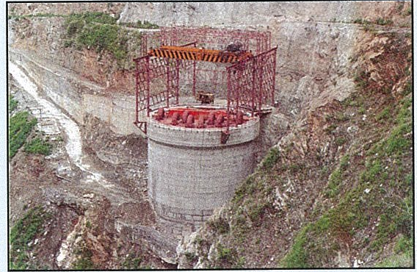

17.2 m dia, 104m high RCC lined restricted orifice type surge shaft.

**Power House**

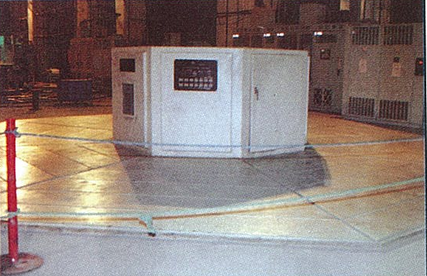

Underground Power House (100m (L)*22 (w)*41.20m (ht.)

has been constructed to house 3 generating units of 100 MW

each.

**Tail Race Tunnel**

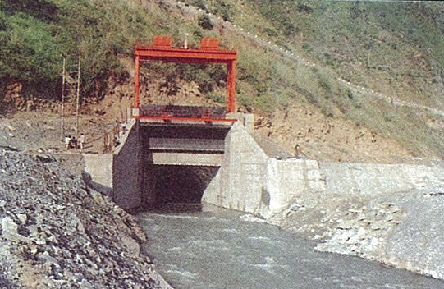

The water discharged from the units will back to river Ravi through a 3.464 KM.long 7 .0m dia Horseshoe shaped Tail Race Tunnel (TRT) .

**GIS &Switchyard**

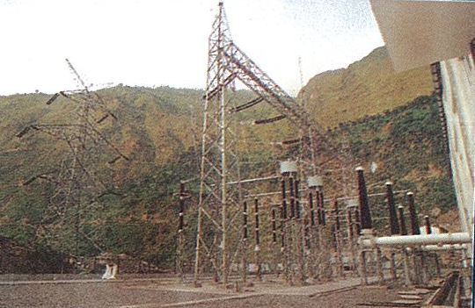

Size 31m*68.8m outdoor on Surface &covered type:GIS SF6 400 KV.

**ORGANISATION CHART OF NHPC CHAMERA POWER STATION-II**

|  |
| --- |
|  |
| G.M |

MANAGER MECH. CE (MECH) MANAGER( FINANCE ) MANAGER( HR) M(C) DAM M(C)COLONY

ACMO-HOSPITAL DM(E) PROCUREMENT

DM(F) DM(F) A.M(HR) A.M(HR) A.M(HR)

M(M) SM(E) ECM M(M) SM (E)-PH

DM(E) HM IT DM(E)OPERATION DM(M) MAINTAINANCE DM(E) OPERATION

DM(M) STORE DM( M)W&T

**HR CHART OF CHAMERA POWER STATION-II**

M (HR)

AM(HR) AM(HR) AM(HR)

PRO AHO

T.O(HR)

O.S

ASSTT ASSTT ASSTT ASSTT ASSTT ASSTT ASSTT

**INTRODUCTION OF EMPLOYEES WELFARE** 

**W**elfare is based concept employees welfare is a comprehensive term including various services, benefits and facilities offered by the employees thought such a generous fringe benefits the employers makes life worth living for employees the welfare amenities extend in addition to normal wages & other economic rewards available to employees as per the legal provision.

The various welfare measures provided by the employees will have immediate impart on the health, physical & mental efficiency, alertness, moral & overall efficiency of the workers & there b contribution to the highest productivity.

Welfare measures may also be provided by the government trade unions, and non-government agencies in addition to the employer. The basics purpose of welfare facility is to enrich the life of employees and keep them happy and contended

Welfare includes anything that is done for the comfort and improvement of employees and is provided over and above the wages. Welfare helps in keeping the morale and motivation of the employees high so as to retain the employees for longer duration. The welfare measures need not be in monetary terms only but in any kind/forms. Employee welfare includes monitoring of working conditions, creation of industrial harmony through infrastructure for health, and insurance against disease, accident and unemployment for the workers and their families.  
  
Labor welfare entails all those activities of employer which are directed towards providing the employees with certain facilities and services in addition to wages or salaries.

**OBJECTIVES OF EMPLOYEES WELFARE**

1. To provide better life and health to the workers
2. To make the workers happy and satisfied
3. To relieve workers from industrial fatigue and to improve intellectual, cultural and material conditions of living of the workers.

**FEATURES OF EMPLOYEES WELFARE**

1. Labor welfare includes various facilities, services and amenities provided to workers for improving their health, efficiency, economic betterment and social status.
2. Welfare measures are in addition to regular wages and other economic benefits available to workers due to legal provisions and collective bargaining
3. Labor welfare schemes are flexible and ever-changing. New welfare measures are added to the existing ones from time to time.
4. Welfare measures may be introduced by the employers, government, employees or by any social or charitable agency.
5. The purpose of labor welfare is to bring about the development of the whole personality of the workers to make a better workforce.

**EMPLOYEES WELFARE SCHEME IN CPS-II**

Organization provides welfare facilities to their employees to keep their motivation levels high. The employee welfare schemes can be classified into two categories viz. statutory and non-statutory welfare schemes. The statutory schemes are those schemes that are compulsory to provide by an organization as compliance to the laws governing employee health and safety. These include provisions provided in industrial acts like Factories Act 1948, Dock Workers Act (safety, health and welfare) 1986, Mines Act 1962. The non statutory schemes differ from organization to organization and from industry to industry.

**STATUTORY WELFARE SCHEME IN CPS-II**

**The statutory welfare schemes include the following provisions:**

1. **Drinking Water: -** At all the working places safe hygienic drinking water should be provided.
2. **Facilities for sitting: -** In every organization, especially factories, suitable seating arrangements are to be provided.
3. **First aid appliances: -** First aid appliances are to be provided and should be readily assessable so that in case of any minor accident initial medication can be provided to the needed employee.
4. **Latrines and Urinals: -** A sufficient number of latrines and urinals are to be provided in the office and factory premises and are also to be maintained in a neat and clean condition.
5. **Canteen facilities: -** Cafeteria or canteens are to be provided by the employer so as to provide hygienic and nutritious food to the employees.
6. **Spittoons:-** In every work place, such as ware houses, store places, in the dock area and office premises spittoons are to be provided in convenient places and same are to be maintained in a hygienic condition.
7. **Lighting: -** Proper and sufficient lights are to be provided for employees so that they can work safely.
8. **Washing places:-** Adequate washing places such as bathrooms, wash basins with tap and tap on the stand pipe are provided in the port area in the vicinity of the work places.
9. **Changing rooms: -** Adequate changing rooms are to be provided for workers to change their cloth in the factory area and office premises. Adequate lockers are also provided to the workers to keep their clothes and belongings.
10. **Rest rooms: -** Adequate numbers of restrooms are provided to the workers with provisions of water supply, wash basins, toilets, bathrooms, etc.

**NON-STATUTORY SCHEMES IN NHPC CPS-II**

**Many non statutory welfare schemes may include the following schemes:**

1. **Medical facility**- NHPC CPS-II has its own project hospital, which provides medical services to their employees.

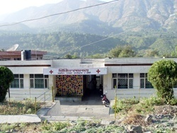

1. **Transport facility:-** NHPC CPS-II provides transport facility to their employee.
2. **Maternity & Adoption Leave:-** Employees can avail maternity or adoption leaves. Paternity leave policies have also been introduced by various companies.

4**. Medi-claim Insurance Scheme:-** This insurance scheme provides adequate insurance coverage of employees for expenses related to hospitalization due to illness, disease or injury or pregnancy.

5. **House Building Advance**:- For HBA only the employees are eligible who have completed probation period and is not superannuating within 36 months can get upto 7.5 lakh.

6. **Prohabiilation of physically handicapped Employees:-** Corporate is paying special attention towards the rehabilitation of physically handicapped employees. Necessary financial assistance is provided to those who get physically handicapped while in service of the corporation.

7. **Gym facility**: - The organization has provided gym facility to their employees.

8. **Uniform: -** A uniform is a set of standard clothing worn by members of an organization. A comfortable Uniform in Summer & Winter has been provided by the organization only for its Workman. The workman who uses to wear a cap is also making available by the organization.

9. **HOSTEL SUBSIDY: -** Hostel subsidy is provided by NHPC for the Children of employee.RS.1500 per month is restricted to 2 Children.

10. **GOOD working condition:-** Working condition in CPS-II are excellent the environment is neat and clean everywhere & at, premises gardening is done so that greenery is there the pleasant environment of CPS-II keeps employees fit & fine.

11**. LIBRARY: -** In CPS- II a Library is provided by the organization. There are all kinds of Books are available in the Library. The Books are available in Hindi & English. The reader is able to find the books of their own choice. The most important thing that the library is capable of saving precious reading time by guiding the reader to a book he wants to read.

12. **EDUCATION FACILITY:-** A Central school has been opened at at Karian in July,2000 and the classes was started from First to Fifth standard. But now the school is being upgraded to Tenth Standard

13 **INSURANCE: -** Social insurance is also one of the major functions of the Organization. Organization wants to make its employee socially secure. Insurance is done by the organization only for its regular employees. Insurance is done for:

|  |
| --- |
| 1.Death |
| 2.Loss of limb or sight |
| 3.Permanent total / Partial disablement |

13. **TRANSPORTATION:**-The committee on labor welfare,1969, recommended the provision of transport facilities to workers. Bus service has been provided by NHPC in CPS II for all its employees. By Bus service the employees can reach at their work place with punctuality and comfortably.

**CHAPTER - 2**

**OBJECTIVES OF THE STUDY**

**OBJECTIVES OF THE STUDY**

1. To study the welfare facilities in CPS II & its impact on employees.

2 .Are the employees satisfied with the welfare activities provided by company?

3. To study what kind of facilities the employees want in their company.

4. To have their suggestion to improve or add new welfare facilities.

**CHAPTER-3**

**RESEARCH METHODOLOGY**

Research Methodology is a way to systematically solve the research problem. The Research Methodology includes the various methods and techniques for conducting a Research. It is a procedure of logical and systematic application of the fundamentals of science to the general and overall questions of a study and scientific technique, which provide precise tools, specific procedures, and technical rather philosophical means for getting and ordering the data prior to their logical analysis and manipulating different type of research designs is available depending upon the nature of research project, availability of manpower and circumstances**.**

Research is thus, an original contribution to the existing stock of knowledge making for its advancement. The project has a specified framework for collecting data in an effective manner. Such framework is called **“Research Design.”** The research process followed by us consists of following steps:

* **Research Design: -**A research design is the arrangement of conditions for collection and analysis of data in a manner that aims to combine relevance to the research purpose with economy in procedure. In fact, the research design is the conceptual structure within which research is conducted**.** Descriptive research design was used for the study.
* **Descriptive Research:-**The research was descriptive because the major objective was to describe the human resource development practices carried out in organization and the ground work for the study was available.
* **Sampling Design: -** Sampling can be defined as the section of some part of an aggregate or totality on the basis of which judgment or an inference about aggregate or totality is made. The sampling design helps in decision making in following areas:-
* **Universe: -** The universe of the study was employees working in NHPC Limited in India.
* **Sampling Frame:-**.Sample frame refers to various sources from where information about the respondents is extracted. The sources of information were HR manager, HR executive, Supervisors and officers.
* **Sample Size: –** The sample size of the study was 50.
* **Sample Unit**: **–** It indicates who is to be surveyed. The researcher must define the target population that will be sampled. In this project sampling unit was employees of NHPC Chamera Power Station –II.
* **Sampling Technique:** - This refers to a procedure by which the respondent should be chosen. Non- probability Convenience sampling technique was used to collect the data. Sometimes called grab or opportunity sampling, this is the method of choosing items arbitrarily and in an unstructured manner from the frame.

**CHAPTER- 4**

**DATA COLLECTION, ANALYSIS AND INTERPETATION**

**Data Collection: –** The data was collected from both Secondary and Primary sources.

* **Secondary Sources: –**Secondary data are those which have already been collected by someone else and which already had been passed through statistical process. Secondary data was collected through Websites, Books, and official’s documents.
* **Primary Sources: -** Primary data is first hand information and thus happen to be original. Data was collected through interview, observation and Questionnaire was prepared in order to get first hand information.

**Data Analysis And Interpretation**

|  |  |  |  |
| --- | --- | --- | --- |
| Sr.no | Questions | Yes | No |
| 1 | Whether the employees are happy with the overall health and safety facilities provided by the company? | 92% | 8% |
| 2 | Do you come across stress at your workplace? | 40% | 60% |
| 3 | Would you to have a stress management committee to train employees to cope up with stress? | 76% | 24% |
| 4 | Is your health affected by workplace environment? | 30% | 70% |
| 5 | NHPC is providing seven days of theoretical & practical training for all employees. I am satisfied with training provided by the company? | 80% | 20% |
| 6 | We have good sitting arrangements in the office as well as in the canteen. | 94% | 6% |
| 7 | The first aid box with prescribed contents is available in my work place? | 46% | 54% |
| 8 | Welfare measure motivates us to perform better. | 84% | 16% |
| 9 | Welfare activities promote harmonious relations between management & employees? | 86% | 14% |
| 10 | Welfare activities & morale has direct relationship.? | 84% | 16% |
| 11 | We are provided with satisfactory facilities for entertainment & recreation? | 96% | 4% |
| 12 | I am satisfied with overall welfare activities of the company? | 94% | 6% |

|  |  |  |  |  |  |
| --- | --- | --- | --- | --- | --- |
| Sr.no | Question | excellent | Good | satisfactory | Unsatisfactory |
| 13 | How well the controlling officers handle the employees’ problem in routine? | 28% | 40% | 32% | 0% |
| 14 | The services provided by the project hospital are? | 16% | 54% | 24% | 6% |
| 15 | What do you think transportation system at CPS-II is? | 8% | 56% | 30% | 6% |
| 16 | Which type of accommodation provided by the company is? | 30% | 44% | 26% | 0% |
| 17 | The drinking water facility is available at all important locations are? | 18% | 54% | 24% | 4% |

|  |  |  |  |
| --- | --- | --- | --- |
| **Sr.no** | **Question** | **Yes** | **No** |
| **1** | **Whether the employees are happy with the overall health and safety facilities provided by the company?** | **92%** | **8%** |

**Interpretation:**

The figure shows that 92% of employees are happy with the overall health and safety facilities provided by the company and only 8% of employees are not happy with the overall health and safety facilities provided by the company.

|  |  |  |  |
| --- | --- | --- | --- |
| **Sr.No.** | **Question** | **Yes** | **No** |
| **2** | **Do you come across stress at your workplace?** | **40%** | **60%** |

**Interpretation:**

The above figure shows that 40% of the employees come across stress at their workplace while 60% employees don’t come across any stress at their workplace. The above description shows that maximum number of respondents is not come across at the workplace.

|  |  |  |  |
| --- | --- | --- | --- |
| **Sr.No.** | **Question** | **Yes** | **No** |
| **3** | **Would you like to have a stress management committee to train employees to cope up with stress?** | **76 %** | **24 %** |

**Interpretation**:

The above figure shows that 76% employees of NHPC CPS-II are in the favour to have a stress management committee in their organization to train employees to cope up with stress and 24% employees think that it’s not necessary to have a stress management committee.

|  |  |  |  |
| --- | --- | --- | --- |
| **Sr. No** | **Question** | **Yes** | **No** |
| **4** | **Is your health affected by workplace environment?** | **30%** | **70%** |

**Interpretation:**

The above figure represents that 30% employees feel that working environment affects their health and rest of the 70% employees don’t feel so.

|  |  |  |  |
| --- | --- | --- | --- |
| **Sr. No.** | **Question** | **Yes** | **No** |
| **5** | **NHPC is providing seven days of theoretical & practical training for all employees. I am satisfied with training provided by the company?** | **80%** | **20%** |

**Interpretation:**

The above figure shows that 80% employees of chamera power station-II are satisfied with the seven days theoretical and practical training provided by the NHPC and only 20% and unsatisfied.

|  |  |  |  |
| --- | --- | --- | --- |
| **Sr.No.** | **Question** | **Yes** | **No** |
| **6** | **We have good sitting arrangements in the office as well as in the canteen.** | **94%** | **6%** |

**Interpretation:**

The above figure shows that 94% employees are satisfied with the sitting arrangements in the office as well as in the canteen also but 6% employees are not satisfied with the sitting arrangements in the office and canteen.

|  |  |  |  |
| --- | --- | --- | --- |
| **Sr. No.** | **Question** | **Yes** | **No** |
| **7** | **The first aid box with prescribed contents is available in my work place?** | **46%** | **54%** |

**Interpretation:**

The above figure shows that 46% employees have first aid box facilities at their workplaces and 54% employees are unsatisfied with this facility.

|  |  |  |  |
| --- | --- | --- | --- |
| **Sr. No.** | **Question** | **Yes** | **No** |
| **8** | **Welfare activities motivate us to perform better?** | **84%** | **16%** |

**Interpretation:**

The above figure shows that 84% employees are agreed that welfare activities motivates us to perform better and only 16% employees are not get motivated by the welfare activities.

|  |  |  |  |
| --- | --- | --- | --- |
| **Sr. No.** | **Question** | **Yes** | **No** |
| **9** | **Welfare activities promote harmonious relations between management & employees?** | **86%** | **14%** |

**Interpretation:**

The above figure represents that 86% employees think that welfare activities promotes harmonious relation between management & employees and 14% employees don’t think that welfare activities promotes harmonious relation between management and employees.

|  |  |  |  |
| --- | --- | --- | --- |
| **Sr. No.** | **Question** | **Yes** | **No** |
| **10** | **Welfare activities & morale has direct relationship.** | **84%** | **16%** |

**Interpretation:**

The above figure shows that 84% employees are agreed that welfare activities and morale has direct relationship and the welfare activities increase their morale but 16% employees are not in the favour of the above question.

|  |  |  |  |
| --- | --- | --- | --- |
| **Sr. No.** | **Question** | **Yes** | **No** |
| **11** | **We are provided with satisfactory facilities for entertainment & recreation?** | **96%** | **4%** |

**Interpretation:**

The above figure shows that 96% employees are satisfied with the entertainment and recreation facilities provided by the company and 4% employees are unsatisfied with the entertainment and recreation facilities provided by the company.

|  |  |  |  |
| --- | --- | --- | --- |
| **Sr.No.** | **Question** | **Yes** | **No** |
| **12** | **I am satisfied with overall welfare activities of the company?** | **96%** | **4%** |

**Interpretation:**

The above figure shows that 94% employees are satisfied with the overall welfare activities of the company and only 4% employees are not satisfied with the overall welfare activities of the company.

|  |  |  |  |  |  |
| --- | --- | --- | --- | --- | --- |
| **Sr.No.** | **Question** | **Excellent** | **Good** | **Satisfactory** | **Unsatisfactory** |
| **13** | **How well the controlling officers handle the employee’s problem in routine?** | **28%** | **40%** | **32%** | **0%** |

**Interpretation:**

From the above figure it is very clear that the problems of 28% employees are excellently handled by the controlling officers when they come across any problem in their routine work and 40% employees think that they handle their problems in a good way and 32% employees are satisfied with their controlling officers.

|  |  |  |  |  |  |
| --- | --- | --- | --- | --- | --- |
| **Sr.no.** | **Question** | **Excellent** | **Good** | **Satisfactory** | **Unsatisfactory** |
| **14** | **The services provided by the project hospital are?** | **16%** | **54%** | **24%** | **6%** |

**Interpretation:**

The above figure shows that 16% employees of NHPC CPS-II are in the favour that services provided by the project hospital are excellent, 54% employees said that the services provided by the hospital are good, 24% employees are satisfied with the services of the project hospital and 6% employees are unsatisfied.

|  |  |  |  |  |  |
| --- | --- | --- | --- | --- | --- |
| **Sr. No.** | **Question** | **Excellent** | **Good** | **Satisfactory** | **Unsatisfactory** |
| **15** | **What do you think transportation system at CPS-II is?** | **8%** | **56%** | **30%** | **6%** |

**Interpretation:**

The above diagram shows that 8% employees say that transportation system at Chamera power station-II is excellent, 56% employees say that it is good, 30% employees say that it is satisfactory and 6% employees are unsatisfied with the transportation system at NHPC CPS-II.

|  |  |  |  |  |  |
| --- | --- | --- | --- | --- | --- |
| **Sr.No.** | **Question** | **Excellent** | **Good** | **Satisfactory** | **Unsatisfactory** |
| **16** | **Which type of accommodation provided by the company is?** | **30%** | **44%** | **26%** | **0%** |

**Interpretation:**

The above diagram shows that 30% respondents say that the accommodation facility provided by the company is excellent, 44% employees say that it is good, 26% employees say that it is satisfactory.

|  |  |  |  |  |  |
| --- | --- | --- | --- | --- | --- |
| **Sr.No.** | **Question** | **Excellent** | **Good** | **Satisfactory** | **Unsatisfactory** |
| **17** | **The drinking water facility is available at all important locations are?** | **18%** | **54%** | **24%** | **4%** |

**Interpretation:**

The above diagram shows that that 18% employees say that drinking water facility available at all important locations of the organization is excellent, 54% employees say that drinking water facility available at all important locations of the organization is good, 24% employees say that it is satisfactory and 4% employees say that it is unsatisfactory.

**CHAPTER-5**

**FINDINGS**

Employee welfare facilities provided by the NHPC Chamera Power Station-II are very good. The company provides different welfare facilities to their employees like transportation, hospital, KVS school facility, housing facility, drinking water facility, canteen facility and scada hall facility etc. And I studied over all these welfare facilities provided by the company to their employees for my project study and I found that most of the employees are very happy with the welfare facilities of NHPC at Chamera Power Station-II.

**CHAPTER – 6**

**LIMITATIONS OF THE STUDY**

Due to constraints of time and resources, the study was likely to suffer from certain limitations. Some of these are mentioned here under so that the findings of the study may be understood in a proper perspective.

The limitations of the study were as follows:

* The research was carried out in a short period. Due to paucity of time a small sample size has been taken and the parameters were selected accordingly so as to finish the work within the given time frame. It may not be sufficient to predict the result with 100% accuracy.
* Complete information was not available due to confidentiality of information kept by the organization.
* The information given by the respondents might be biased some of them might not be interested to give correct information.
* Some of the respondents of the survey were unwilling to share information.
* Scheduled working hours of the employees did not allow us to have much interaction with them.
* Since the convenience technique sampling has been used in the study, the sample was not a fully representative of the universe.

**CHAPTER -7**

**RECOMMENDATIONS**

After studying all the welfare activities at NHPC Chamera Power Station-II, I should like to recommend the company that some of the employees were not happy with the first aid box facilities at their working place and few were not happy with sitting arrangement and other facilities like transportation so I recommend that they took the suitable steps to fullfill this gap so that the satisfaction level of the employees would definatly increase and they will work more willingly and the company will move to heights of acheivements.

**CHAPTER- 8**

**CONCLUSION**

**Conclusion**

Employee Welfare is an important part of organizational climate. Concept employee’s welfare is a comprehensive term including various services, benefits and facilities offered by the employees thought such a generous fringe benefits the employers makes life worth living for employees the welfare amenities extend in addition to normal wages & other economic rewards available to employees as per the legal provision. For the purpose of study I Design that a questionnaire consisting of 17 questions on different facilities provided to employees by the organization e.g. hospital facility, accommodation facility, drinking water facility, transportation system etc.It was distributed among the executive and non executive staff in different section/Department for taking response. The technique used for sampling was stratified random sampling and the size of the sample taken up for study was 50 out of which were 18 from executive section and 32 from non-executive section.

The employees of both Categories are very much satisfied with the welfare facilities of NHPC. The working conditions and the welfare policy of NHPC are very good. On the basis of above discussion I come to the conclusion that the Employee welfare facilities of NHPC are excellent.

**ANNEXURE**

**Questionnaire**

Sir/Madam

I am the student of MBA 3rd semester **in *ICL INSTITUTE OF ENGINEERING AND TECHNOLOGY COLLEGES SOUNTLI( AMBALA)*.** Your co-operation for the completion of my project report titled ***“EMPLOYEE WELFARE*”** is very humbly solicited in order to get the true picture of the ***WELFARE MEASURES OF NHPC CPS-II*.** It is extremely important that your response should be accurate and reflecting your feelings. Therefore you are requested to answer the questionnaire. I assure that the information given by you will be used for academic purpose only and will not be divulged to any individual and agencies including print or electronic media.

|  |  |  |  |
| --- | --- | --- | --- |
| **Designation** |  | **Male/ Female** |  |
| **Division** |  | **Service Tenure** |  |

**Please tick mark the relevant answer as provided against each question.**  
  
1) Whether the employees are happy with the overall health and safety facilities provided by the company?  
  
a) Yes ( ) b) No ( )  
  
2) Do you come across stress at your workplace?   
  
a) Yes ( ) b) No ( )

3) Would you like to have a stress management committee to train employees to cope up   
with stress?  
  
a) Yes ( ) b) No ( )   
  
4) Is your health affected by workplace environment?  
  
a) Yes ( ) b) No ( )

5)NHPC is providing Seven days of theoretical & practical training for all employees. I am satisfied with training provided by the company?

(a) Yes ( ) (b) No ( )

6) We have good sitting arrangement in the office as well as in the canteen?

(a) Yes ( ) (b) No ( )

7) The First aid box with prescribed contents is available in my work place?

(a) Yes ( ) (b) No ( )

8) Welfare measures motivate us to perform better?

(a) Yes ( ) (b) No ( )

9) Welfare activities promote Harmonious relations between management & employees?

(a) Yes ( ) (b) No ( )

10) Welfare activities & Morale has direct relationship?

(a) Yes ( ) (b) No ( )

11) We are provided with satisfactory facilities for entertainment & recreation?

(a) Yes ( ) (b) No ( )

12) I am satisfied with overall welfare activity of the Corporation?

(a) Yes ( ) (b) No ( )

13) How well the controlling officers handle the employee’s problems in routine?

a)Excellent( ) b) Good ( ) c) satisfactory ( ) d) unsatisfactory ( )

14) The services provided by the Project Hospital are?

1. Excellent( ) b) Good ( ) c) satisfactory ( ) d) unsatisfactory ( )

15) What do you think, Transportation system at CPS II is?

1. Excellent( ) b) Good ( ) c) satisfactory ( ) d) unsatisfactory ( )

16) Which type of Accommodation provided by the company is?

1. Excellent( ) b) Good ( ) c) satisfactory ( ) d) unsatisfactory ( )

17) The Drinking facility is available at all Important locations are?

1. Excellent( ) b) Good ( ) c) satisfactory ( ) d) unsatisfactory ( )

**BIBLIOGRAPHY**

1. Stephenson P. Robbins, *Organizational Behavior*, New Delhi, Prentice Hall of India 1989 p. 527.
2. Theodore T. Hebert, *op.cit.* p.575
3. Keith Davis News Storm,op.cit.,292
4. M.Beer, *Organizational Change and Development, A system* View *California*, Good Year publishing Co., 1980

**URL’s**

1. "http://www.nhpcindia.com/
2. www. Google.com